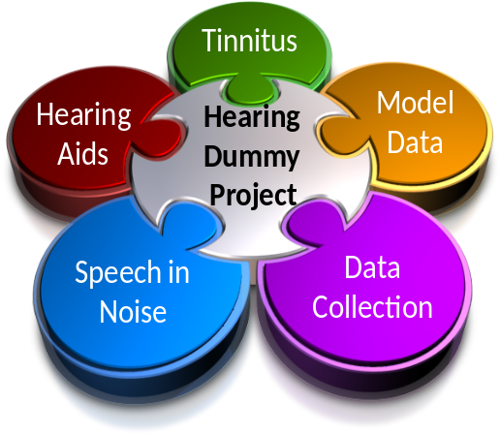
ReadMe MAP1_14

Welcome to the Matlab Auditory Periphery modelling and testing suite.
This package contains software used in the ‘Hearing Dummy’ project. It three main components are, the MAP software, multiThreshold software and auditory profiles.

MAP.
The Matlab Auditory Periphery (MAP) is a computer model of the physiological basis of human hearing. This package contains open-source computer code to allow you to run the model and develop the code for your own use. MAP 1_14 is a new and (fairly stable) release with numerous improvements on earlier versions.

multiThreshold
The aim of the model is to offer an account of normal and impaired hearing using human data collected using the multiThreshold system for rapid acquisition of psychophysical data. The open-source code for running this software is also included in this package.

Profiles.
MultiThreshold can be used to acquire auditory profiles of the hearing of individuals. A database of around 70 profiles has already been acquired for people with either good or impaired hearing. These profiles are also included in the package.
Guides to getting started can be found in the Documentation folder:
- A guide to installation and getting started with the MAP modelling software can be found in Documentation\multiThreshold Quick Start.docx
- If you are primarily interested in the multiThreshold patient testing software, check out the Documentation\multiThreshold Quick Start.docx
- The profiles can be accessed after reading Documentation\Auditory profiles.doc

